IP-WC-2011-50-07145 McDill Pond Channels Dredging Amendment
McDill Inland Lake Protection and Rehabilitation District

Current issue:
In Winter 2012 the South Channel of McDill Pond was dredged to remove sediment material that caused the water to go uphill to exit the channel. Since the dredging was completed, several homeowners on the channel have brought to attention other areas they would like dredged to improve navigation. Currently there are several areas in the channel where sediment has accumulated, causing navigation issues where boaters must pull their motors up, or are unable to navigate through with a gas propelled engine. The areas have also experienced a closing of the springs, causing poor water quality. The last major dredge of the channel was completed in the early 1960’s, and over the years sediment has accumulated at several different locations. Dredging would improve the water quality and open up navigations for about 70 residences and the general public on the channel of McDill Pond.

The next set of photos are of the various different dredge locations that are being requested to be amended in the permit.
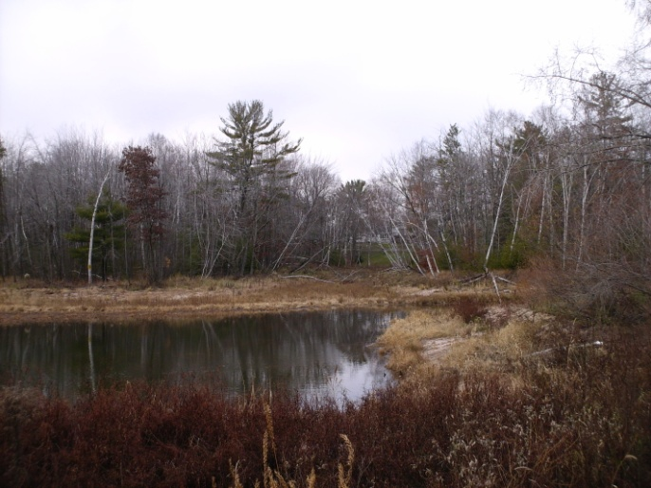  Area 1, around the islands. Notice the water has stopped flowing around the islands, and it has shallowed to the point that boats have difficulty navigating through | 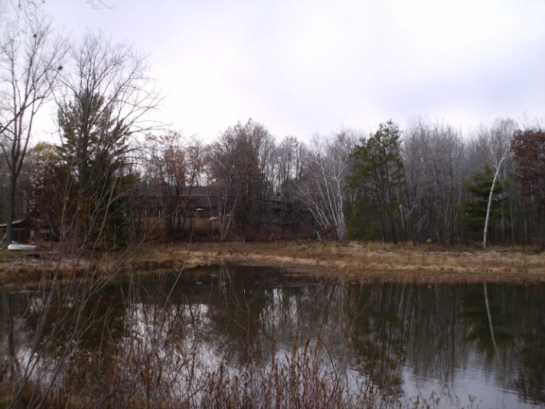  Area 1 – other opening of the island, again too shallow and narrowed for boat navigation due to sediment buildup
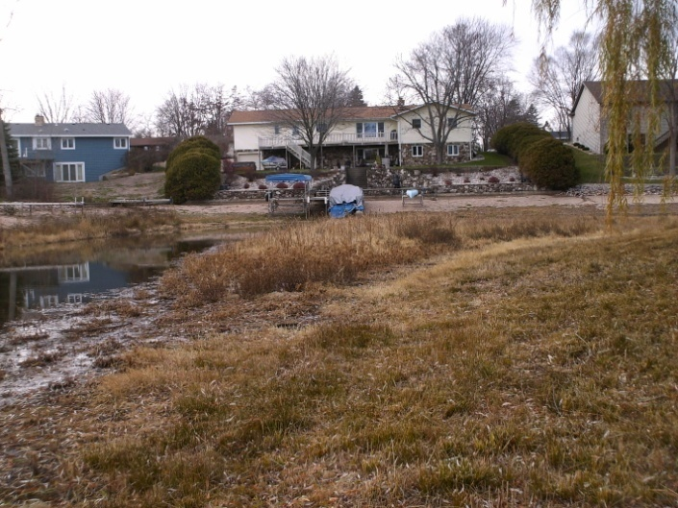  Area 2 – Horseshoe of South Channel, area has accumulated sediment around the bend causing difficulty for navigation by homeowners | 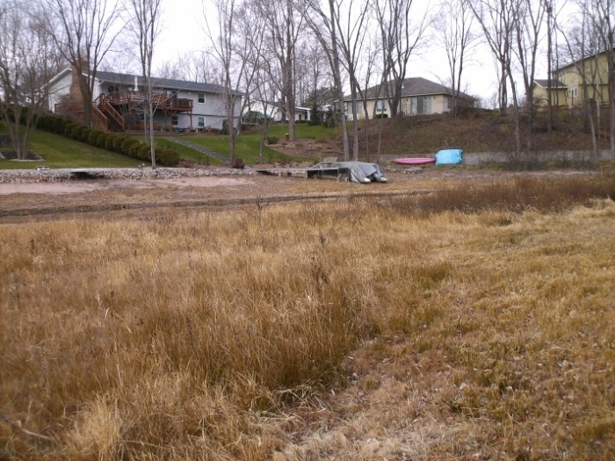  Area 2 further around the bend of the horseshoe
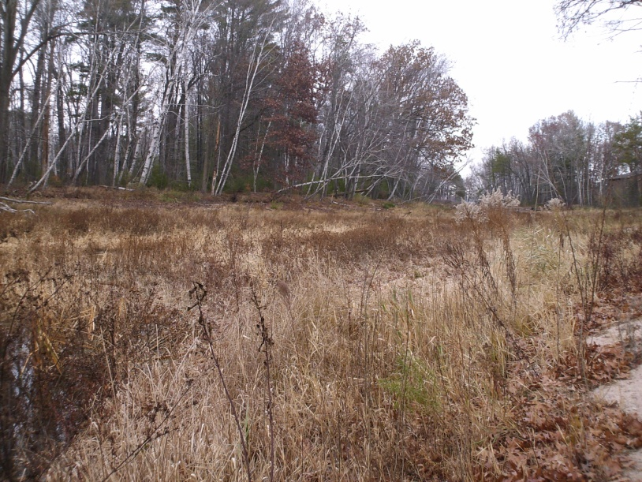  Area 3 – we stopped too short last year on the Della St Channel Dredge where the water doesn’t continue to flow out, and now there is a hill between one section and the previously dredged area. | 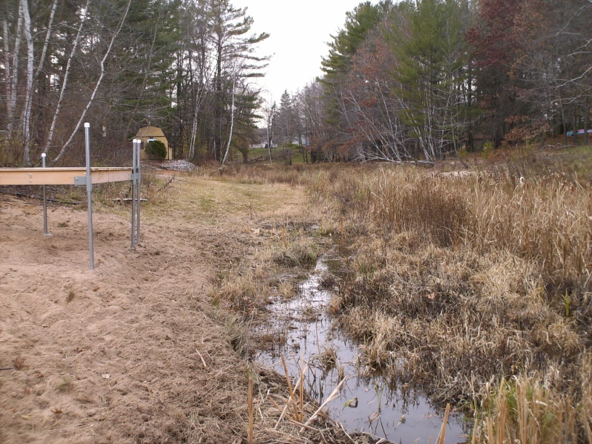  Area 4 – Area in front of Rasmussen residence, again an uphill area that needs to be leveled off so boats don’t hit their props on the bottom
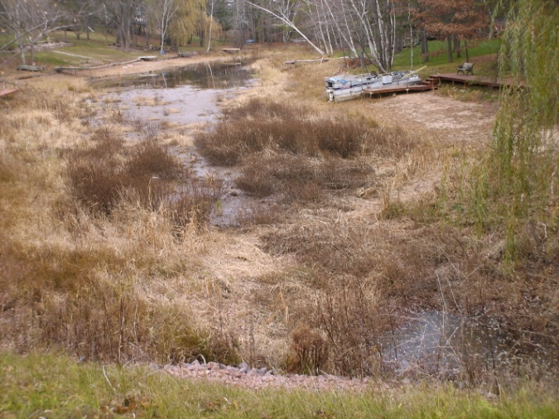
Area 5 – North Channel right before the culvert, the area is filling in with sediment, and boats are not able to make a proper turnaround without having to raise motors

Proposed Materials: Construcks Trucking and Excavating has been selected as the contractor. Excavating would use backhoe and catapillar to scoop and remove excess lake bed material, which is a combination of black muck buildup from decaying plant material and sand. The work we would like to complete between beginning of January and end of February to allow equipment to drive on the lakebed while it is froze. Due to the lakebed access area being frozen and snow covered erosion from other areas would be minimal, and any need to provide silt fencing will be completed if the weather is unusually warm creating erosion issues. The excavated areas would be smoothed out to create a natural curve contour to the bottom of the lakebed. Any disturbed shoreline areas would be replanted with grass or naturalizing grass mix in spring.

Spoils Disposal: The excavated material would be transported to and spread at two different locations. The first location is owned by Lake District Member Ken Lepak, at 6693 County Highway J. The remaining material will be hauled to 2608 Water St Stevens Point WI 54481, rented by Ken Lepak. Excavated material on the Lepak property would be spread across the farmfield area to build an access road on the Lepak property with proper erosion control. Map of locations is shown below.
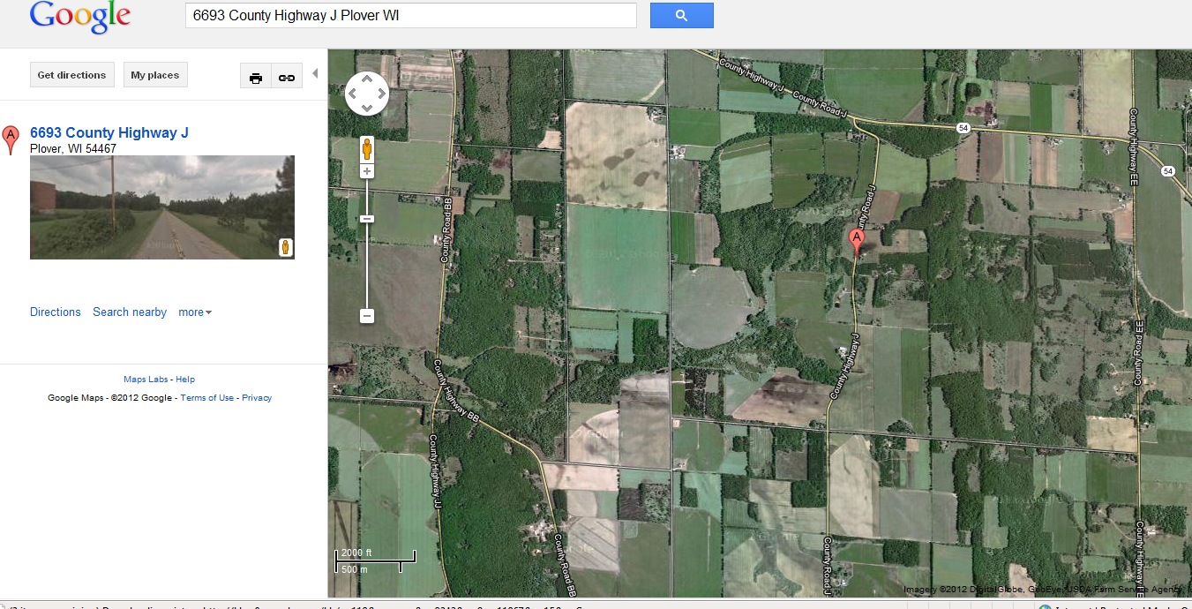

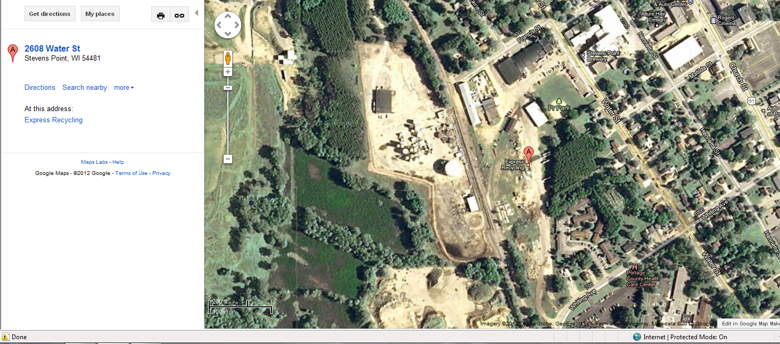

The areas on the map below would be dredged to remove a 2 – 3’ deep path approximately 14’ wide. Two homeowners have requested that deepholes up to 5’ deep be dredged off their dock for fish habitat, one at 3216 Della St, the other at 3136 Dans Dr, pending DNR approval. The Della Street pathway that was used last year for dredging along with the Riverwoods park area would be used to access dredge locations on the South Channel. The North channel dredge areas would be accessed through private landowner properties, which have agreed to the access through their property. Funding of the project is being handled by donations from homeowners.

Full McDill Pond view map with the two dredge areas
Area 5 N Channel Culvert
Area 4 Rasmussens
Area 3 Remainder missed
Area 2 HorseShoe
Area 1 S Channel Islands

