**IP-WC-2012-##-##### McDill Pond Island Channels Dredging**

**McDill Inland Lake Protection and Rehabilitation District**

**Current issue:**

In Winter 2012 the South Channel of McDill Pond was dredged to remove sediment material that caused the water to go uphill to exit the channel. Since the dredging was completed, several homeowners on the channel have brought to attention other areas they would like dredged to improve navigation. Currently there are several areas in the channel around the islands where sediment has accumulated, causing navigation issues where boaters must pull their motors up, or are unable to navigate through with a gas propelled engine. The areas have also experienced a closing of the springs, causing poor water quality. The last major dredge of the channel was completed in the early 1960’s, and over the years sediment has accumulated at several different locations. During survey work of the area around the islands improper disposal of construction materials was also found, which would be removed with a dredge. Dredging would improve the water quality and open up navigations for about 70 residences and the general public on the island channel of McDill Pond.

The next set of photos are of the various different dredge locations that are being requested to be amended in the permit.

|  |  |
| --- | --- |
| HPIM4041.JPG  Area 1, around the islands. Notice the water has stopped flowing around the islands, and it has shallowed to the point that boats have difficulty navigating through | HPIM4042.JPG  Area 1 – other opening of the island, again too shallow and narrowed for boat navigation due to sediment buildup |
| Area 2 – | Area 2 |
| Area 3 –. | Area 4 – Area in front of Rasmussen residence, again an uphill area that needs to be leveled off so boats don’t hit their props on the bottom |
| Area 5 – North Channel right before the culvert, the area is filling in with sediment, and boats are not able to make a proper turnaround without having to raise motors |  |

**Proposed Materials:**  A site survey was done by lake district members to find areas around the island that are currently not 3’ deep when water is back at normal levels. To be on the safe side the group used the high water mark vs ordinary water mark to make sure they were marking the true shallow areas. Stakes with flags were placed in the channel to indicate height and flagged where they were too shallow. Construcks Trucking and Excavating has been selected as the contractor, and will excavate the areas flagged as too shallow. Construcks would use a backhoe and catapillar to scoop and remove excess lake bed material, which is a combination of black muck buildup from decaying plant material and sand. The work we would like to complete between beginning of January and end of February to allow equipment to drive on the lakebed while it is froze. Due to the lakebed access area being frozen and snow covered erosion from other areas would be minimal, and any need to provide silt fencing will be completed if the weather is unusually warm creating erosion issues. The excavated areas would be smoothed out to create a natural curve contour to the bottom of the lakebed. Any disturbed shoreline areas would be replanted with grass or naturalizing grass mix in spring.

**Spoils Disposal:** The excavated material would be transported to and spread at 2608 Water St Stevens Point WI 54481, land rented by Ken Lepak. Map of locations is shown below.

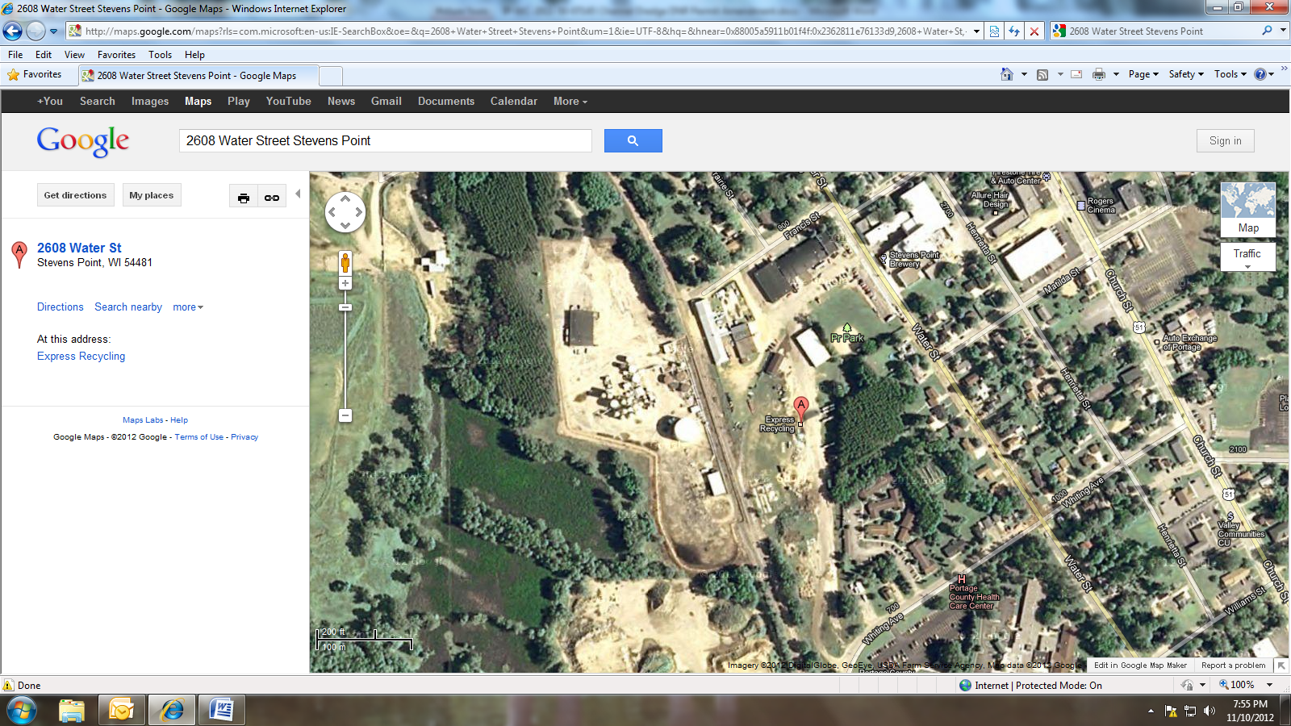

The areas on the map below would be dredged 6 – 12 inches to make a 3’ deep path approximately 14’ wide. The Della Street pathway that was used last year for dredging along with the Riverwoods park area would be used to access the dredge location. Funding of the project is being handled by donations from homeowners.

Full McDill Pond view map with the dredge areas. Blue line is DNR areas to review. Red line is areas found by depth survey that are not 3’ deep during high water, and should be considered for dredging. Please note the two red dots were high spots that were found that should be leveled off the remove navigation hazards. The one at the opening on the north end of the islands is especially narrow and dangerous.

