Photos of Aquatic and Invasive Plants

Below are the common aquatic plants that can be found in McDill Pond. Photos courtesy of Paul Skawinski, Golden Sands RC&D
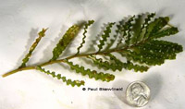  Curly Leaf Pondweed  Wavy round leaves resemble lasagna noodles. Leaf edge is lightly serrated.  Invasive!! | 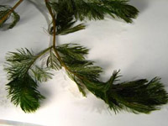  Eurasian Water Milfoil  12-20 pairs of leaflets. Plant is limp out of water  Invasive!!
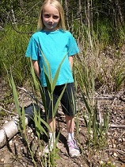  Phragmites  Plant stalks can be over 4’ tall on shorelines  Invasive!! | 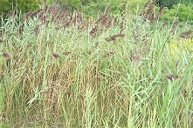  Canary Reed Grass  Grass will grab and cut skin, takes over shorelines  Invasive!!
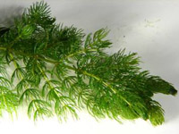  Coontail  Leaves fork 1-2 times, tips are bushy | 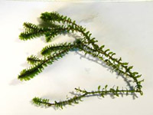  Canadian Waterweed (Elodea)  Leaves in whorl of 3 around stem
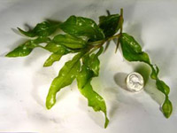  Illinois Pondweed  Larger loose wavy leaves | 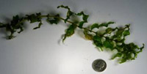  Clasping Leaf Pondweed  Smaller and tighter wavy leaves
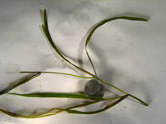  Flat Stem Pondweed  Large long grass-like leaves | 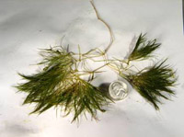  Sago Pondweed  Thin long branching leaves
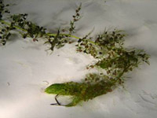  Common Bladderwort  Highly divided leaves, small sacs on leaves eats bugs | 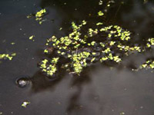  Duckweed  Small round drop like leaflets

