McDill Pond Dredging Proposal
McDill Inland Lake Protection and Rehabilitation District

Current issue:
The Heffron St Channel of McDill has experienced issues over the last few years with poor water quality. This has been compounded by excessive aquatic plant growth, and a lack of flow through the channel. Several different solutions were considered including aerators and water turbines. A survey done by Boonestroo in June 2010 found that part of the contributing factors to the water quality problem is due to the water fighting to get uphill to get out of the channel. The last major dredge of the channel was completed in the early 1960’s, and over the years sediment has accumulated at the mouth of the south channel opening. It was recommended to remove the sediment at the channel opening to improve water flow, along with opening up natural occurring springs. Deepening the channel will also be needed as years by to keep the area clear for navigation. It was also recommended to dredge the Riverwoods pond area of the south channel to open springs to provide more fresh water to the area where water tends to stagnate. This would improve the water quality for about 50 residences on the channel of McDill Pond.

The unexpected drawdown of 2011 has allowed McDill Lake District the opportunity to go back and fix the channel issue that was not completed during the 2008-09 drawdown. In the next set of photos you can see where sediment has accumulated at the end of the south channel, forcing the exiting water to go uphill. These photos were taken from the dead end cul de sac of Della Street heading to the exit of the south channel by the Enerson residence.
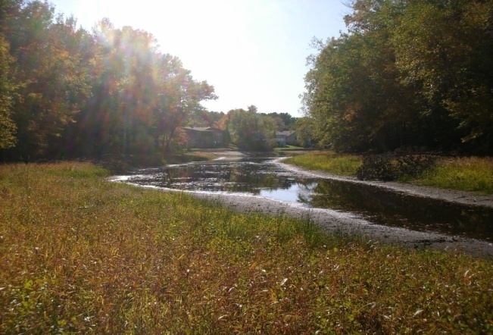 | 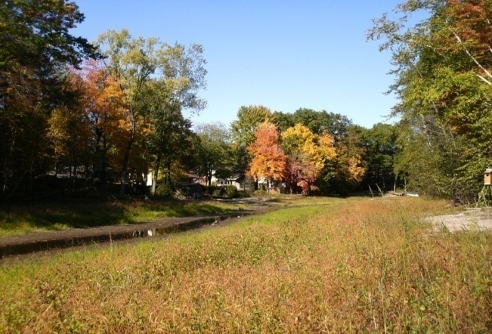
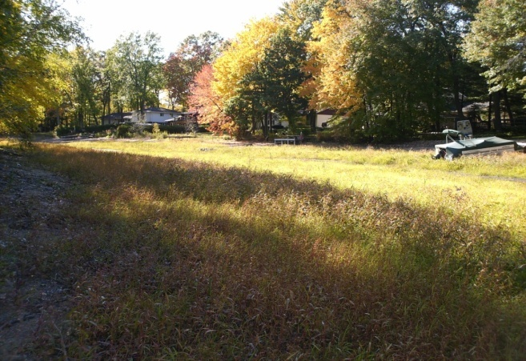 | 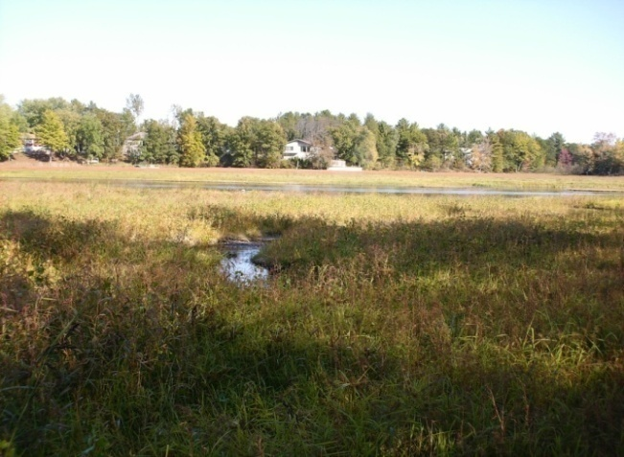

The pictures above are the channel from top (l-r) and bottom (l-r) order from the dead end cul de Sac of Della heading towards the opening of the South channel into the main body of McDill pond. Notice at the bottom that the stream is down to a narrow trickle.

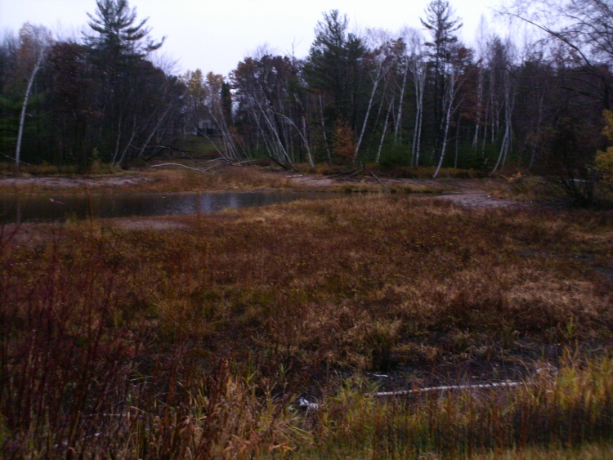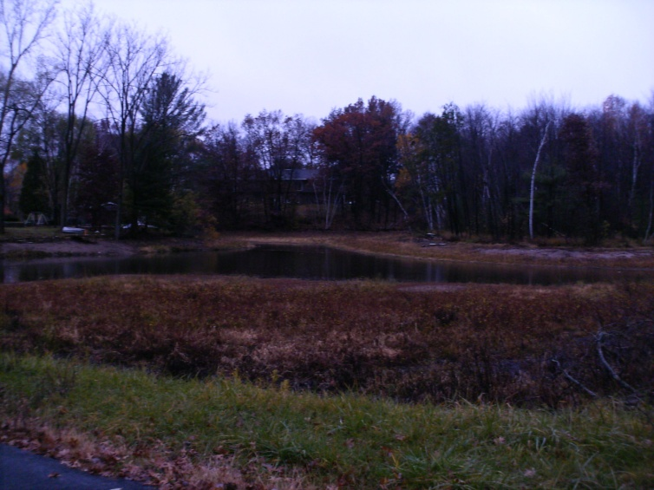
Picture or Riverwoods park dredge area. Notice stream area where water still flows, dirt area is where sediment has accumulated blocking springs.

Proposed Materials: Stucyinski Excavating would use backhoe, bulldozer, catapillar, etc to scoop and remove excess lake bed material, which is mainly a black muck buildup from decaying plant material. The work we would like to complete between beginning of January and end of February to allow equipment to drive on the lakebed while it is froze. Due to the lakebed access area being frozen and snow covered erosion from other areas would be minimal, and any need to provide silt fencing will be completed if the weather is unusually warm creating erosion issues. The excavated areas would be smoothed out to create a natural curve contour to the bottom of the lakebed. Any disturbed shoreline areas would be replanted with grass or naturalizing grass mix in spring.

Spoils Disposal: The excavated material would be transported to and spread at the David Enerson Farm, Westfork Farm, 1353 West River Dr W Stevens Point. Westfork farm is a DNR approved disposal site for McDill Lake District for disposal of harvested aquatic plant material. Map of location of land is shown below. The location is about 7 miles from the excavation location of McDill pond. Excavated material would be spread across the farmfield area and worked into the existing field in the spring. The fields/dumping locations are not located next to the waterway.
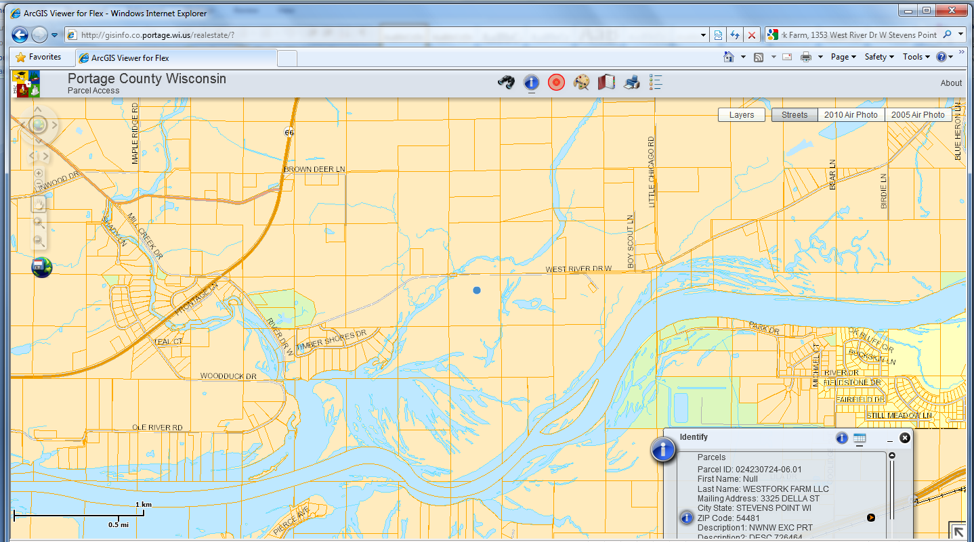

The recommendation from Stuczyinski Excavating is to remove a 2 – 3’ deep path approximately 14’ wide in the areas shown on the map below for the stretch from the dead end of Della St to the south channel opening. The depth would go deeper as they move towards the exit to make a silt trap for the future years. The Riverwoods pond area would also be accessed via city right of way and Stuczyinski private residence to remove approximately 2 – 3’ depth of the excess muck in an area 50 x 75’ to re-open the springs.

A pathway for the trucks would need to be cut into the dead end of Della Street on city parkland. The land is currently used as a trail, most often by ice fisherman during the winter months. A path can be easily cut by removing a dead oak, a scrubby jack pine, and a few other small scrub trees. A small load of gravel would need to be put down at the end of the cul de sac to even out the trail for the trucks to drive on.

Funding of the project has been approved by the Lake District 2010-2011 budget and/or fundraisers McDill is considering to fund repairs to McDill. The Lake District has requested the city for right of way access for Stuczyinski’s equipment, and permissions to dredge the land as officially the exposed lake bed is shown to be under ownership of the city and the deceased Dan Koziczikowski who build the channels and subdivision. All of Dan’s surviving children have signed off on a letter giving permission for the project.

South Channel Opening
Riverwood Park Area
Full McDill Pond view map with the two dredge areas

Dan’s Drive
Riverwoods Park
Della St
Up close dredge location map Yellow areas are dredge areas.
McDill Pond South Channel Dredge Quote
Areas in Yellow in above map are proposed dredge locations. Costs for the dredge are listed below
Riverwoods Park Bay
Excavate and remove material from bay (75'x50x3')
Load and haul 520yds to Enerson Farm $1500

Della St. Channel
Load haul and level (900'x14'x3') 1,750yds, $7,500
Load haul and transport to Enerson Farm Add $3,000
* Pending DNR approvals for excavation and disposal
Per Joe Stuczyinski: I think deepening the exsisting channel would not be cost effective for the amount of sand we would remove, beyond the Della St. limits. I would have to use Off-Road trucks for the Della St. channel, where as highway trucks would be more cost effective on Heffron and Riverwoods. Excavating would be completed by Joe Stuczynski at cost by Stuczynski Trucking and Excavating Inc (Lake District Member)

